Time Series Unit 1/HW 1 Solutions

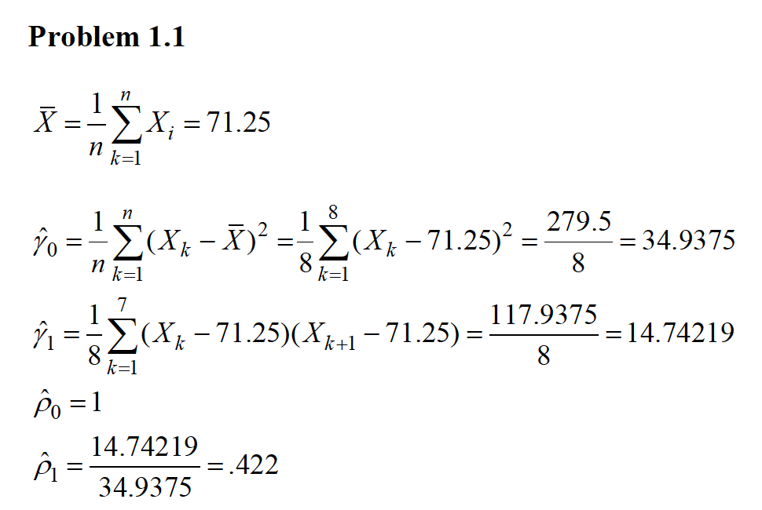

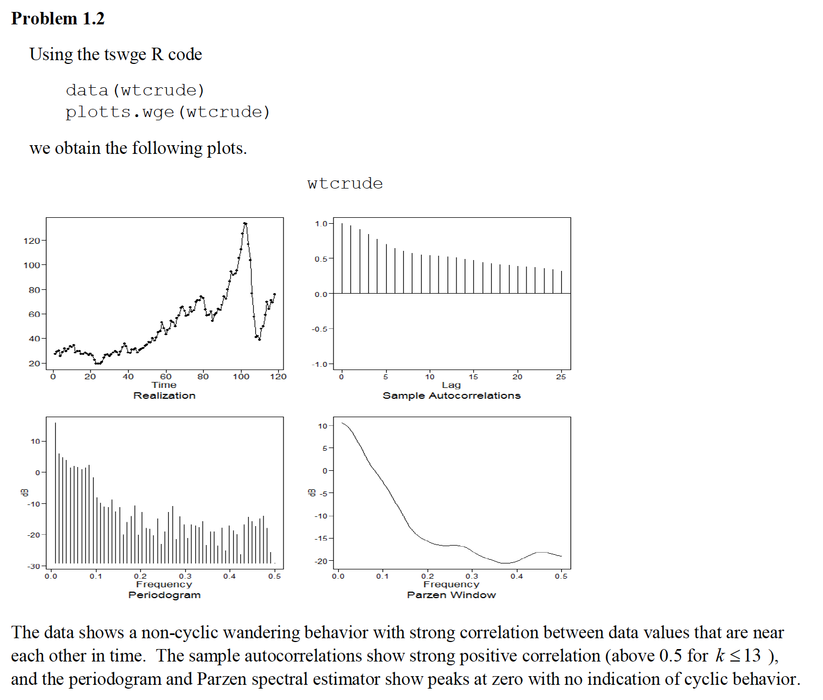

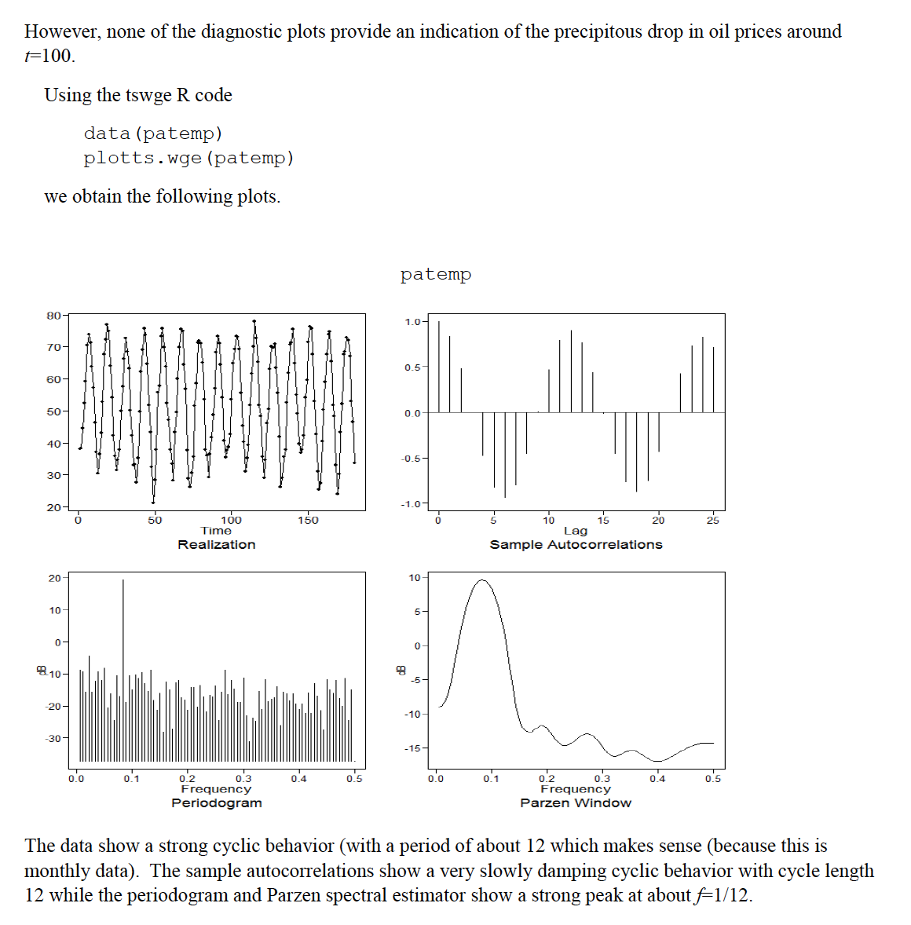

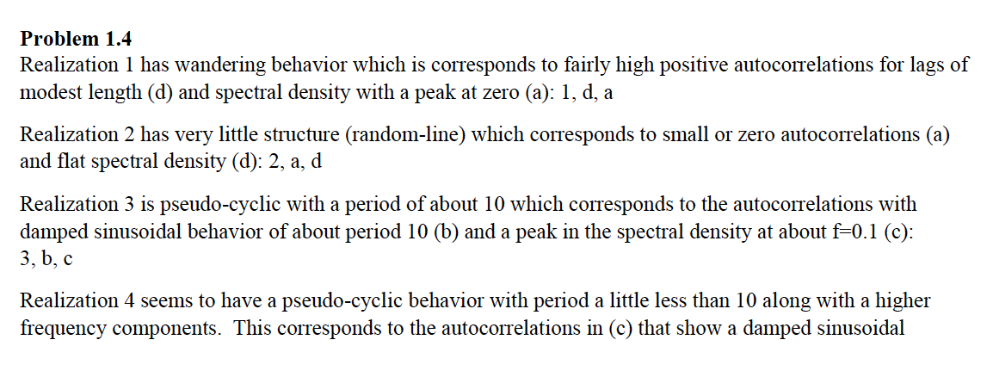



**Problem 1.5**

data("fig1.21a")

parzen.wge(fig1.21a,dbcalc = FALSE)

parzen.wge(fig1.21a,dbcalc = TRUE)

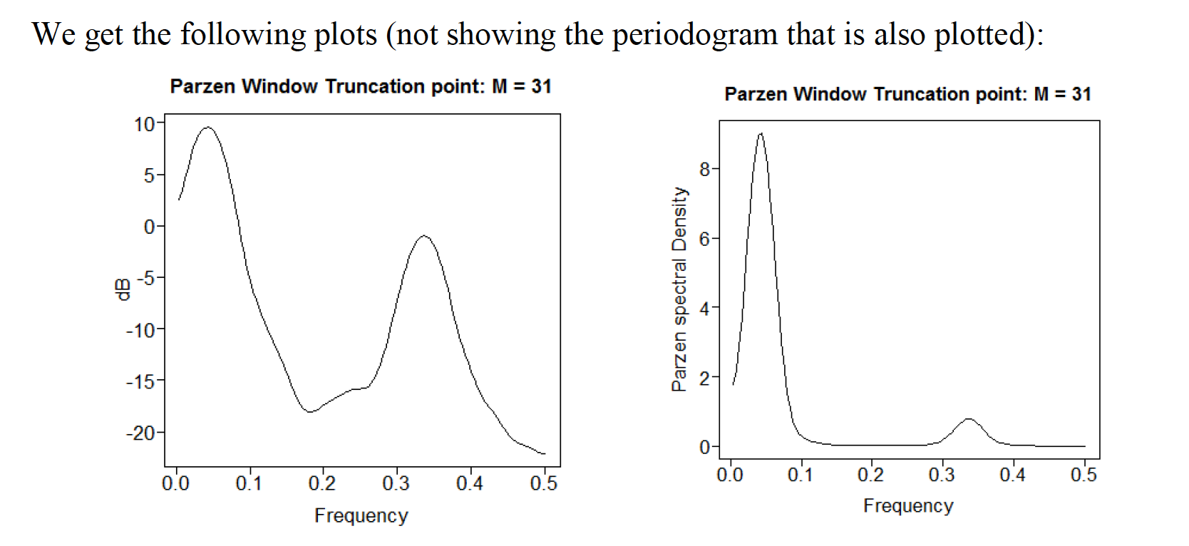

Both show strong indication of a peak at abouit *f*=0.05. However, the plot in dB shows the secondary peak at about *f*=0.33 much more clearly.

**Problem 1.6**

For UNIT 1 … only a – c are assigned. (d will be in Unit 2).

